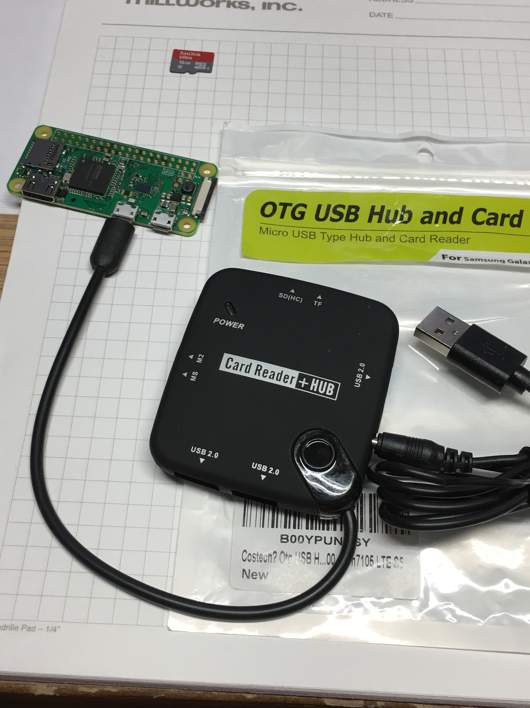

This is a wireless packet station that does not require a dedicated computer or usb port. A raspberry Pi Zero W is configured as a WiFi to Serial bridge in order to connect to the TNC from any computer on your wireless network.

In order to connect to the packet station you first run a SSH client on the computer you wish to use to access the packet tnc.

The SSH program I use is called “Putty” and is a free download from www.putty.org. You run Putty and then enter the local IP address of your WiFi bridge Raspberry Pi. When you SSH into the Raspberry Pi you should get the command line login prompt from the Raspberry Pi. It will ask your user name followed by your password for the Raspberry Pi.

After logging in to the Raspberry Pi you will use a linux communications program to connect to the tnc by way of the usb port on the Raspberry Pi. After connecting to the tnc you will see the normal tnc welcome screen and after hitting return you will be in the command mode where you are able to check your bbs or your mh list or connect to another packet station.

This sounds complicated but it's really easy once all the parts are configured and connected together.

First download the latest version of Raspbian from www.RaspberryPi.org. I use “Win32Diskimager” to write the Raspbian image to the micro sd card.

Next I use a OTG Hub and card reader that has a USB power cord and a micro USB cable input. This hub is made for reading sd cards and thumb drives from a cell phone but it also gives us 3 usb ports for the Raspberry Pi Zero. If you choose to use a Raspberry Pi 2 or 3 the hub won't be needed.

Now it is time to connect a keyboard and mouse and a monitor to the Raspberry Pi either directly or via the USB hub. Power up the Raspberry Pi and configure it for keyboard and locale and set it up to access your wireless network. Once it is set up on your wireless network it is a good idea to update the system and then download the application “minicom” if it was not included in the latest release of raspbian.

From the terminal window enter “ifconfig” and write down the ip address of the Raspberry Pi. With the ip address you can now run Putty on your PC ans SSH into the Raspberry Pi where you will be presented with the user and password prompts.

Next open the terminal window and enter “$ dmesg | grep tty “ on the command line. This will identify the USB ports connected to the Pi. If your tnc has a USB interface all you need to do is identify the USB port that you will be connecting the tnc to. If your tnc needs a serial connection with a db9 or db25 connector then you will need to use a USB to Serial adapter cable. The linux operating system on the Pi should automatically load the drivers for that serial device and set up a new serial port on the Pi. Enter $ “dmesg | grep tty “ on the command line and you should see something that will identify your serial port with a label similar to “ttyUSB0” This is what we are looking for.

With the tnc powered on and the USB to serial cable connected ( you may need a db9 to db25 adapter ) we can connect to the tnc by typing “minicom -D /dev/ttyUSB0 -b 9600 -o” on the command line. The /dev/ttyUSB0 refers to your serial port and the -b 9600 refers to the baud rate. Some tnc's such as the PK232 expect a 1200 baud connection with 7 data bits and even parity so the command will be different.

That command should connect you to the tnc if everything is set up properly. If so the next thing to do is create an alias of that connection command.

From the Raspberry Pi command line enter “ls -al” . This should list all the files on the /home/pi directory. Look for a file named “.bash_aliases”. If it is not there then create it – don't forget to put the dot in the file name.
Next edit the .bash_aliases file and enter the following line....

alias tnc="minicom mycom -D /dev/ttyUSB0 -b 9600 -o"

I use “tnc” but you can enter anything you like to invoke the command such as KPC3 or PK232 for example.

All the linux commands about the aliases came from Jamie AB7II. Thanks again Jamie!

Good Luck and 73's
Dave WA5X

